Best Management Practices (“BMPs”) for Non-COMMERCIAL Gardening

at Disposal Sites
WSC # 14-910

This document provides guidance on the use of Best Management Practices or “BMPs” for gardening at locations within the boundary of a disposal site cleaned up pursuant to the Massachusetts Contingency Plan (MCP), 310 CMR 40.0000.
This document is intended solely as guidance. It is not a regulation, rule or requirement, and should not be construed as mandatory. It does not create any substantive or procedural rights, and is not enforceable by any party in any administrative proceeding with the Commonwealth. This document provides guidance on approaches the Massachusetts Department of Environmental Protection (MassDEP) considers acceptable for meeting requirements set forth in the MCP. Parties using this guidance should be aware that other acceptable alternatives may be available for achieving and documenting compliance with the applicable regulatory requirements and performance standards of the MCP.

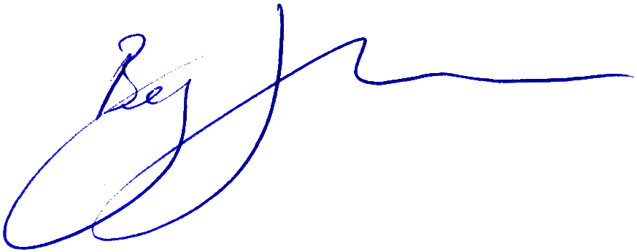

________________________________
Benjamin J. Ericson
Assistant Commissioner

12/31/14

1.0 Introduction: Why Should Gardening Best Management Practices Be Used?
It is not uncommon for properties in Massachusetts to have measurable levels – usually low levels – of contaminants such as lead or petroleum hydrocarbons in soil. These contaminants may be present from natural sources or as a result of human activities on or around the property. Some contamination may require cleanup based on the standards published by the Massachusetts Department of Environmental Protection (MassDEP) in 310 CMR 40.0000, the Massachusetts Contingency Plan (MCP), although even properties that have been cleaned up under the MCP will likely have measurable residual levels of some contaminants remaining in the soil. Such residual levels are safe and protective when they meet the cleanup requirements.

MassDEP recognizes that in a residential setting, yards and gardens are areas where people are most likely to have increased direct and indirect contact with soils, and that many gardeners may wish to further reduce their exposure to even residual contaminants in soil. Therefore MassDEP has developed recommendations for practical techniques, or Best Management Practices (“BMPs”), for non-commercial gardening in areas that may still contain residual levels of contaminants. These BMPs are consistent with national guidance on urban gardening and reflect a consensus among gardening experts on measures that effectively reduce exposure to common contaminants that may occur through non-commercial gardening. They work by isolating the garden from any contamination remaining in the soil below through the use of impermeable barriers and/or raised garden beds, and other relatively simple, common sense measures.

In all cases, the use of the recommended BMPs is optional. The inclusion of BMPs and a recommendation for their use in an MCP Permanent Solution Statement that documents the disposal site assessment and cleanup is required in specific circumstances, however, to inform current and future occupants of a property of practical methods to further reduce exposure to residual soil contaminants during gardening.

2.0 Purpose

The purpose of this guidance is to support Potentially Responsible Parties and Licensed Site Professionals in preparing those Permanent Solution Statements that, pursuant to 310 CMR 1056(2)(j)1 and based on a Method 3 risk characterization, require inclusion of “the recommendation and description of Best Management Practices for Non-commercial Gardening in a residential setting to minimize and control potential risk qualitatively evaluated pursuant to 310 CMR 40.0923(3)(c).” More generally, beyond the required recommendation for BMPs under the MCP, MassDEP encourages the optional use these gardening BMPs or similar measures by gardeners in residential settings who wish to reduce their potential exposure to soil contaminants.

3.0 Scope and Applicability

The following provisions are relevant to including the recommendation of gardening BMPs in a Permanent Solution Statement as part of a Permanent Solution with Conditions:
- 310 CMR 40.0006(12) (definition of Best Management Practices for Non-commercial Gardening)
- 310 CMR 40.1056(2)(j)1 (Content of Permanent Solution Statements);
- 310 CMR 40.1041(2)(c)2 (Categories of Permanent Solutions);
- 310 CMR 40.40.1013 (Limitations, Assumptions and Conditions on Site Activities and Uses That Do Not Require an AUL); and
- 310 CMR 40.0923(3)(c) (Identification of Site Activity and Uses).
The MCP defines gardening BMPs as follows:

Best Management Practices for Non-commercial Gardening means current practices generally accepted by practitioners of safe gardening methods that limit potential human exposure to OHM during gardening activities and as the result of consumption of fruits and vegetables grown in a non-commercial garden. Such practices include, but are not limited to: locating garden beds outside of areas affected by releases of OHM; gardening in raised beds above a barrier layer; use of soil and soil amendments unaffected by releases of OHM in garden beds; and covering adjacent areas to limit the transfer of OHM from windborne material into garden beds.

As required at 310 CMR 40.1056(2)(j)1, where applicable to disposal sites evaluated using a Method 3 Risk Characterization, “the recommendation and description of Best Management Practices for Non-commercial Gardening in a residential setting to minimize and control potential risk qualitatively evaluated pursuant to 310 CMR 40.0923(3)(c)” must be included in the disposal site Permanent Solution Statement. The gardening BMPs requirement applies to disposal sites that are demonstrated to pose No Significant Risk of Harm to Health using a Method 3 Risk Characterization that includes:
(a) the assumption of unrestricted use (including residential use) of the property;
(b) a quantitative assessment of direct contact exposures (ingestion, dermal contact and inhalation) to soil; and
(c) a qualitative assessment of incremental exposures associated with gardening activities.

In those cases where a quantitative assessment of exposures associated with gardening is conducted and the disposal site is shown to meet risk limits for gardening, then inclusion of gardening BMPs descriptions and a recommendation for their use in the Permanent Solution Statement is not required. Figure 1 below illustrates when inclusion of gardening BMPs descriptions and a recommendation for their use is required as part of a Permanent Solution with Conditions.

Figure 1

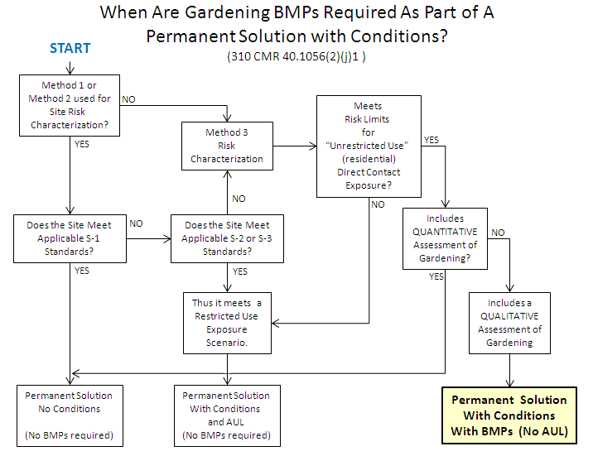

4.0 Best Management Practices for Non-Commercial Gardening
The attachment below, “Best Management Practices for Non-commercial Gardening
at Disposal Sites,” is appropriate for use to meet the requirement at 310 CMR 40.1056(2)(j)1 to include in the Permanent Solution Statement a “recommendation and description of Best Management Practices for Non-commercial Gardening in a residential setting to minimize and control potential risk qualitatively evaluated pursuant to 310 CMR 40.0923(3)(c).”

To highlight and assist readers in locating this information in the Permanent Solution Statement, these BMPs should appear under a distinct heading in the Permanent Solution Statement and be identified as a distinct item in the Table of Contents of the Permanent Solution Statement. The narrative of the Permanent Solution Statement should provide some context for the BMPs, including a reference to recommended use of the BMPs as a condition of the Permanent Solution with Conditions.

Attachment
Best Management Practices for Non-commercial Gardening
at Disposal Sites
Best Management Practices for Non-commercial Gardening
at Disposal Sites

This property is part of a disposal site that has been assessed and determined to meet the requirements of a Permanent Solution with Conditions under the Massachusetts Contingency Plan (MCP), 310 CMR 40.0000, where the Conditions include the recommendation of Best Management Practices (“BMPs”) for gardening to reduce the potential risks from exposure to contaminated soil that remains on the site.

While the property has been determined to be safe for unrestricted use, including residential use, there are residual levels of contaminants remaining in the soil. Gardeners should consider implementing BMPs to further reduce potential exposure to material in the soil, regardless of the contaminant levels remaining. Implementing BMPs such as those suggested below will allow safer gardening in a wider range of site conditions. Not every BMP is necessary for every single site, but a combination of BMPs appropriate for your particular site will help reduce the potential for additional exposure.

Construct Physical Controls and Improve Soil Conditions
Actions to minimize contact (covering the soil) and reduce contaminant levels (such as amending the soil) will further reduce potential risks. Many good gardening practices, like adding compost and soil amendments, improve the soil while reducing the amount of contaminants and exposure to them. Recommendations include:

- Build your garden away from areas known or suspected to be contaminated. In addition to areas where residual contamination may be present, as identified by the disposal site assessment, other sources of contamination can include painted structures (particularly older buildings that may have been painted with lead paint), roads and rail lines.
- Build a hedge or fence to reduce windblown contamination from mobile sources and busy streets.
- Cover existing soil and walkways with mulch, landscape fabric, stones, or bricks.
- Use mulch in your garden beds to reduce dust and soil splash back, reduce weed establishment, regulate soil temperature and moisture, and add organic matter.
- Use soil amendments (such as lime and compost) to maintain neutral pH and add organic matter to improve soil structure.
    - Not all amendments are the same; be sure to choose the right amendments for your soil - amendments that improve conditions at one garden may not work well in others.
    - Keep in mind that each amendment type will have different application amounts and techniques (e.g., rototilling), and may need to be maintained and reapplied (e.g., annually).
    - Be sure to work with your local or state regulatory agency, and ask if your municipality provides free compost or mulch. Obtain compost only from a reputable source that can provide information regarding the quality and type of feedstock used to generate the compost.
- Add topsoil or clean fill from a reputable source that can provide information regarding the quality of the topsoil or fill to ensure the soil is safe for handling by children or gardeners of all ages and for food production.
- Build raised beds or container gardens.
    - Raised beds can be made by simply mounding soil into windrows or by building containers.
    - Raised beds help improve water drainage in heavy clay soils or low-lying areas. They also create accessible gardening locations for many users and allow for more precise soil management.
    - Foot traffic should not be necessary in the bed, so the soil does not become compacted and soil preparation in the coming years is minimized.
    - Place a water permeable fabric cover or geotextile as the bottom layer of your raised bed to further reduce exposure to soils of concern.
    - Sided beds can be made from wood, synthetic wood, stone, concrete block, brick or naturally rot-resistant woods such as cedar and redwood. Avoid using chemical-treated lumber for the raised bed because chemicals used in the treated wood could make their way into the soils and plants.

Minimize Ongoing Contact with or Ingestion of Soil
Actions to further reduce contact with soil during and after gardening activities can also minimize potential risks from any contaminants remaining in the soil.

- Do not use plants grown in contaminated soil for compost.
- Work in the garden when soil is moist or damp to minimize creation of dust.
- Avoid “double-digging” to decrease likelihood of moving deep soils to the surface.
- Wear gloves, long sleeves and pants while gardening to prevent skin exposure;
- Remove gardening shoes and garments before entering the home, and wash gardening clothes separately from other clothing.
- Wash hands after gardening.
- Wash all vegetables thoroughly.

For More Information
These recommended BMPs are consistent with federal, state and local guidance on urban gardening in general. MassDEP has additional information available online at: http://www.mass.gov/eea/agencies/massdep/cleanup/regulations/gardening-best-management-practices-at-disposal-sites.html

